# ICE 2 – Calculator Report

## Screenshot 1

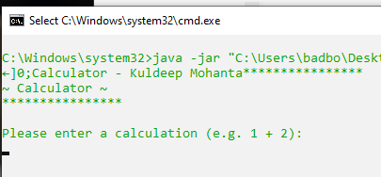

**Description:** As the JAR file opens, the initial screen that the user is presented with is the Welcome banner that states it is a calculator application paired with instructions for the user to input characters.

## Screenshot 2

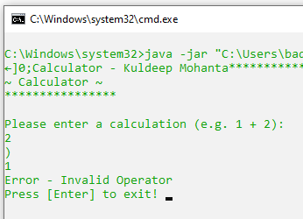

**Description:** If the user inputs a character that is not a pre-defined (common) arithmetic symbol, the program will display an error message to the user along with the incorrect symbol that they used; The program will prompt for input to end the application

## Screenshot 3

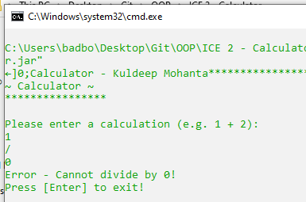

**Description:** The user inputted a 0 value during a division operation which will yield a “divide by 0” error; Followed by the program prompting for input to end the application.

## Screenshot 4

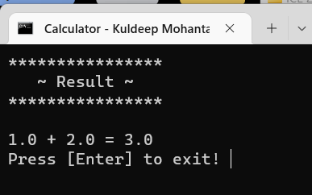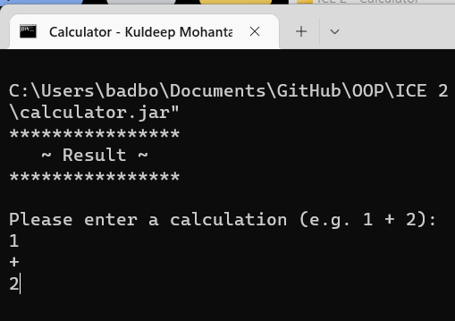

Output window

User Input

**Description:** The user is entering appropriate characters to allow the program to understand as it processes input that it will deal with **an addition expression** in this calculation. After **validating the user’s input**, the program has processed the calculation and **outputs the result with an output banner and finished calculator statemen**t; The program then prompts to end the application.

## Screenshot 5

User Input

Output window

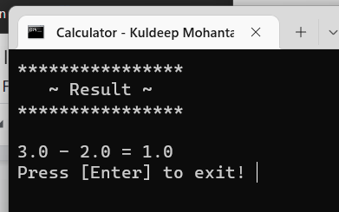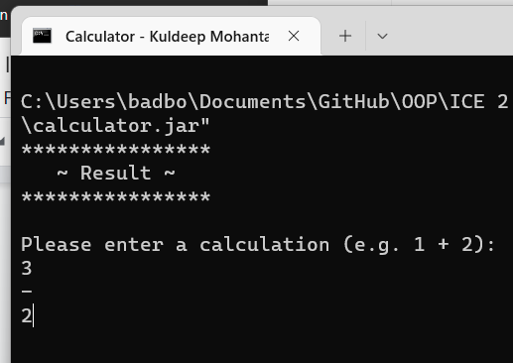

Description: The user is entering appropriate characters to allow the program to understand as it processes input that it will deal with **a subtraction expression** in this calculation. Afte**r validating the user’s input**, the program has processed the calculation and **outputs the result with an output banner and finished calculator statement**; The program then prompts to end the application.

## Screenshot 6

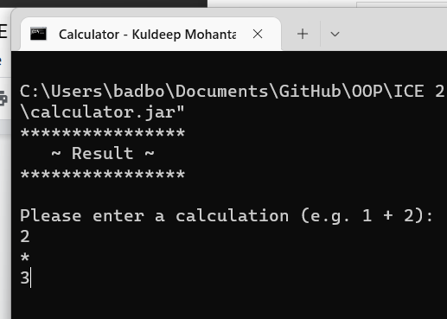

Output window

User Input

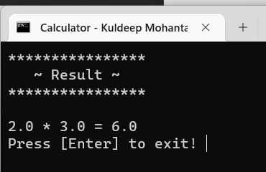

Description: The user is entering appropriate characters to allow the program to understand as it processes input that it will deal with **a multiplication expression** in this calculation. Afte**r validating the user’s input**, the program has processed the calculation and **outputs the result with an output banner and finished calculator statement**; The program then prompts to end the application.

## Screenshot 7

Output window

User Input

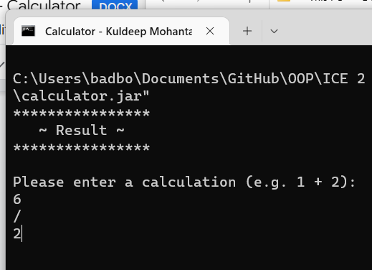

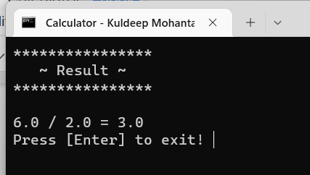

Description: The user is entering appropriate characters to allow the program to understand as it processes input that it will deal with **a division expression** in this calculation. Afte**r validating the user’s input**, the program has processed the calculation and **outputs the result with an output banner and finished calculator statement**; The program then prompts to end the application.